Module 2: A Written Analysis of the Results

Caitlyn Castillo

U of A Bootcamp

08/24/2022

**Overview of Project**

Steve Stocks is newly graduated with a finance degree, and will be helping his parents invest in green stocks. Steve asked the team to complete a deep analysis of 12 stocks (ticker) with 3,013 data points from 2017 and 2018, with a total of 6,026 data points to help decide which stocks will be a strong investment. Due to the amount of data, the team utilized automated tasks available in Visual Basics for Applications (VBA).

**Results**

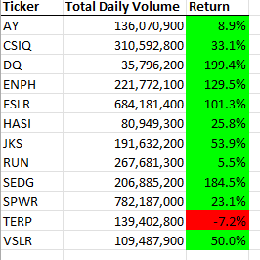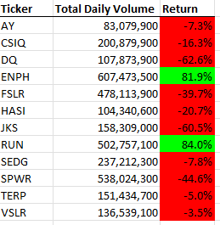

To determine if a stock is worth investing in, comparing a wide range of data over two years shows the volatility and the trend in which the stock is going. In 2017, only one stock, TERP, showed a decline. However, when jumping to 2018, almost all stocks dipped and showed high volatility. If the team was advising on a financial decision, it would be best to not invest in these specific stocks, or to wait to see which stocks begin to trend upwards.

When evaluating the efficacy of the VBA code in practice, the team looked at two factors. First was the accuracy in outputs, by comparing the tables generated by the VBA code to expected tables, the team found that all tickers and values were accurate and accounted for. Second, the team used VBA Timer code to find the amount of time it took to compute, the results are shown below and are much faster than attempting to compile the data by hand.

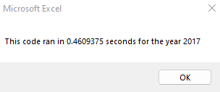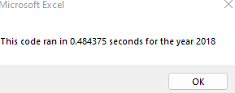

**Summary**

While coding VBA for this analysis, the process of refactoring was used. Refactoring is a process of cleaning and organizing code to increase efficiency, prevent mistakes from building up over time, becoming tangled, or being completely unreadable. There are a few common mistakes to avoid when refactoring in the future. On an individual basis, if refactoring is not done accurately, a coder can change code so much that it no longer works correctly. In large teams, the amount of time and coordination needed can be extensive, and team members may have individualistic styles of clean code.

In this specific analysis, the advantage of the original code was more apparent to the inexperienced VBA coders. The original code, although messy and tangled, read more like a conversation with VBA and was easier to diagnose individual pieces. The obvious disadvantage to this original code is the same, the code was much longer and extremely messy to an experienced VBA coder.